Name __________________________________ Algebra 2 Intro to Statistics

Statistics are numerical values used to summarize and compare sets of data. Two important
types of statistics are measures of central tendency and measures of dispersion.

A measure of central tendency is a number used to represent the center or middle of a set of
data values. The mean, median, and mode are three commonly used measures of central
tendency.

Mean: Sum of the numbers divided by the number of numbers (n). Use $\overline{x}$ to represent the mean.
Median: The middle number when the numbers are written in order. If n is even then the median is the mean of the two middle numbers.
Mode: The most commonly occurring number. There may be one mode, two modes, or no mode at all. Generally, if there is more than two “modes” we say there is “no mode.”

1. Quiz Scores The data set below gives the quiz scores for a student on quizzes consisting of 10 questions each.
7, 9, 7, 10, 8, 7, 9 Find the mean, median, and mode of the data set.

Mean = _____ Median = _____ Mode = _____

2. Oil Change The data set below gives the waiting time (in minutes) of several people having the oil changed in their car at an auto mechanics shop.

22, 18,25,21,28,26,20,28,20 Find the mean, median, and mode of the data set.

Mean = _____ Median = _____ Mode = _____

Measures of Dispersion
A measure of dispersion is a statistic that tells you how dispersed, or spread out, data values are. One simple measure of dispersion is the range, which is the difference between the greatest and least data values.

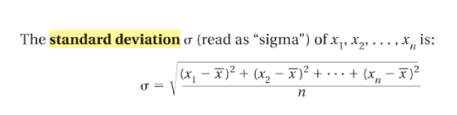
Standard Deviation Another measure of dispersion is standard deviation, which
describes the typical difference (or deviation) between a data value and the mean.

In general, a smaller standard deviation means the data is grouped more “tightly” around the mean and a larger standard deviation means the data is more spread out. We will get more specific about standard deviation later.

Find the range, mean, and standard deviation of the data set.

3. 12,8,17,15,12,14 Range = _______ $\overline{x}$ = _____ σ= ________ (Complete table below.)
Complete the table to find the standard deviation.
x |  |  |  |  |  |  | Sum | $$\frac{Sum}{n}$$ | $$\sqrt{\frac{Sum}{n}}$$
x - $\overline{x}$ |  |  |  |  |  |  | Sum | $$\frac{Sum}{n}$$ | $$\sqrt{\frac{Sum}{n}}$$
(x - $\overline{x})$²

Using Technology
Air Hockey You are competing in an air hockey tournament. The winning scores for the first 10 games are given below.
14, 15, 15, 17, 11, 15, 13, 12, 15, 13
Find the mean, median, mode, range, and standard deviation of the data set.

METHOD
Use a Graphing Calculator You can solve the problem by using a graphing calculator.
STEP 1 Enter the data in list L_{1.} Then press the STAT button, choose the CALC menu, and select 1-Var Stats.
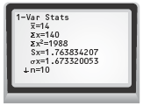
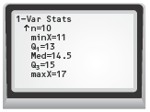
Use the down arrow to see more.

STEP 2 The screen shows a list of statistics.
The mean is x = 14. The standard deviation is σx ≈ 1.7.
Scroll down to see the rest of the statistics. The median (Med) is 14.5. The range is maxX − minX, or 6.
The calculator does not give the mode. By looking at the data, the mode is 15.
PRACTICE
4. Real Estate In the past month, a real estate agent has sold six homes priced at $118,700, $145,300, $174,000, $155,900, $133,500, and $158,000. Find the mean, median, range, and standard deviation of the selling prices.
Mean_______ Median_______ Range_______ Standard Deviation______

5. What If? In Exercise 4, suppose the real estate agent also sold another home during the month priced at $245,000. How does this price affect the mean, median, range, and standard deviation? Compute new values and comment about whey they did or didn’t change.

Mean_______ Median________ Range_______ Standard Deviation_______
What changed? What didn’t? Why?
6. Fat Content The fat contents of seven different sandwiches available at a restaurant are 42, 61, 13, 17, 25, 45,and 30. Find the mean, median, range, and standard deviation of the fat contents.

Mean_______ Median_______ Range_______ Standard Deviation_____

7. Fat Content The fat contents of seven similar sandwiches, from Exercise 6,at a competing restaurant are 25, 40, 9,12, 9, 16, and 18. Find the mean, median, range, and standard deviation of the fat contents. Compare the fat contents of this restaurant and the one in Exercise 6 using the mean, median, and standard deviation.

Mean_______ Median_______ Range_______ Standard Deviation______
Compare:

In addition to the above statistics, the calculator also shows Q1 and Q3. These are called the lower quartile and the upper quartile. The lower quartile is like the “median” of the lower half of the data and the upper quartile is like the “median” of the upper half of the data.
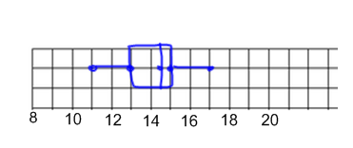
The following stats make up the 5-number summary: Minimum, Lower Quartile, Median, Upper Quartile, Maximum. These 5 numbers split the tate into four sections. Each section contains 25% of the data points.
The 5-number summary can be used to make a box and-whisker plot:
The box and whisker plot shown to the right represents the air hockey scores from earlier: 14, 15, 15, 17, 11, 15, 13, 12, 15, 13 The 5-number summary is:
Min=11, Q1 = 13, Med = 14.5, Q3 = 15, Max = 17

Calculate the 5-number summary and make a box-and-whisker plot of the data.
8. 2, 12, 17, 20, 18, 16, 17, 18, 10, 22 min____ Q1 _____ med_____ Q3_____ max_____
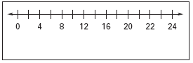
9. 11, 7, 8, 13, 6, 7, 10, 11, 13, 25 min____ Q1 _____ med_____ Q3_____ max_____
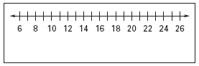
10. 16, 27, 30, 23, 24, 25, 26, 27, 26, 35 min____ Q1 _____ med_____ Q3_____ max_____
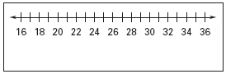

11. 58, 79, 48, 70, 42, 66, 64, 50, 53, 44, 75, 60 min____ Q1 _____ med_____ Q3_____ max_____
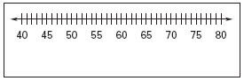
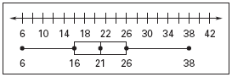
In Exercises 12–14, use the box-and-whisker plot shown below right.

12. About what percent of the data are greater than 26?

13. About what percent of the data are less than 21?

14. About what percent of the data are greater than 16?

Exploration: Data Transformations

Calculate the statistics for each data set. Record the results in the table.
Data Set 1: 2,3,5,7,8,8
Data Set 2: Add 4 to each value in Data Set 1.
Data Set 3: Multiply each value in Data Set 1 by 3.

Data Set | Mean | Median | Mode | Range | Standard Deviation
1
2
3

DRAW CONCLUSIONS
Use your observations to complete the following.
Complete the table above.

15. Compare data sets 1 and 2. Write a rule that explains what happens to the statistics of a data set when a constant is added to each value.

16. Will the rule you wrote in Exercise 15 hold true when a constant is subtracted from each value of a data set? Provide an example to support your answer.

17. Compare data sets 1 and 3. Write a rule that explains what happens to the statistics of a data set when each value of the data set is multiplied by a constant.

18. Will the rule you wrote in Exercise 17 hold true when each value of a data set is divided by a constant? Provide an example to support your answer.

Problem Solving

19. Multi-Step Problem The data set below gives the original prices of six refrigerators sold by an appliance store. The store is having a three-day sale in which all refrigerators are 15% off.
$420,$600, $630, $450, $550, $480

  - Find the mean, median, mode, range, and standard deviation of the original prices and of the sale prices.

  - Suppose the store had instead offered a fixed $50 discount on each refrigerator. Compare the effects of this discount on the measures of central tendency and dispersion with the effects of the 15% discount.

20. Multi-Step Problem The tables below shows the average precipitation
(in inches) for each month of the year in Mobile, Alabama and in Chicago, Illinois.

Average Monthly Precipitation
Mobile, AL | Chicago, IL
5.75, 5.10, 7.20,  5.06, 6.10, 5.01,  6.54, 6.20, 5.01,  3.25, 5.41, 4.66, | 1.75, 1.63, 2.65,  3.68, 3.38, 3.63,  3.51, 4.62, 3.27,  2.71, 3.01, 2.43,

- Find the mean, median, range, and standard deviation of the average precipitation in Mobile, Alabama.

- Find the mean, median, range, and standard deviation of the average precipitation in Chicago, Illinois.

- Compare the statistics for each set of data. What is one conclusion you can make about the data?

21. Open-Ended Give an example of a data set of seven different values that has a mean of 45. Apply a transformation to the data values that changes the mean from 45 to 30.

22. Extended Response The data set below gives the ages of employees at a company.
32, 34, 44, 35, 48, 62, 37, 40, 59

- Find the mean, median, range, and standard deviation of the ages.

- Which data values would you consider to be outliers? Explain.

- Find the mean, median, range, and standard deviation of the ages when the outliers identified in part (b) are not included.

- Which of the statistics is most affected by the outliers? Which is least affected by the outliers?

23. Short Response Two football teammates record their times (in seconds) for five trials in the 40-yard dash. The times are listed in the table.

Trial | Teammate 1 | Teammate 2
1 | 4.48 | 4.24
2 | 4.39 | 4.28
3 | 4.42 | 4.21
4 | 4.33 | 4.30
5 | 4.35 | 4.27

- Find the mean, median, range, and standard deviation of each teammate’s times.

- Which teammate has the more consistent times? Explain your reasoning.

24. The data set below gives the average points per game for the 5 starters of a boys’ high school basketball team at the beginning of the year.
12,8, 15,6,19

By the end of the year, each player increased his average by 3 points. What is the average points per game for a starter of the basketball team at the end of the year?

